Registering a device for the POS
Scenario: FC is emailing because they want to register a new POS device.

- Open the app and begin the setup steps.
- Edit the time and choose North America as the region and Central Time as the time zone.
- Tap NEXT.

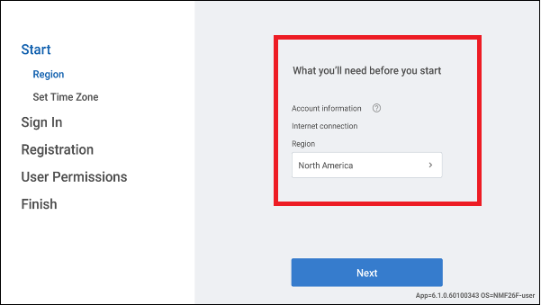

- Enter your username and password registered in Back Office and tap LOGIN.
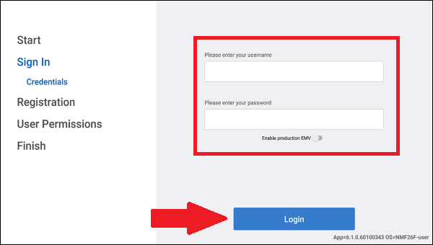

- Tap Select Store option. The Select Store screen appears.
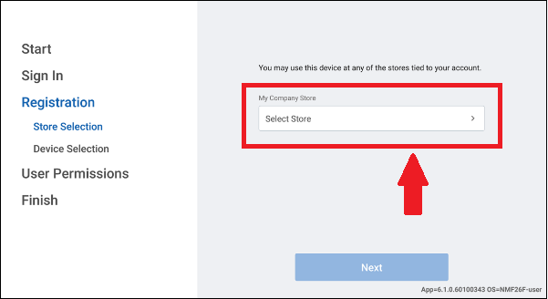

- Select the store tied to your account and tap DONE.
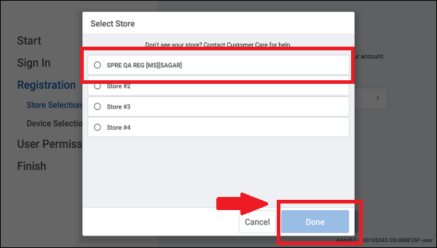

- Tap NEXT.
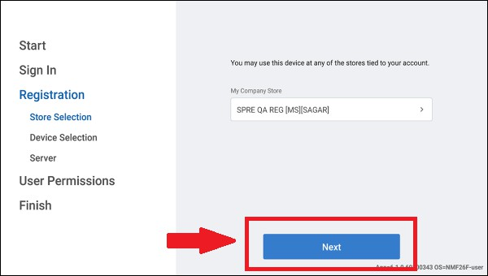

- Enter a unique device name for Descriptive Device Name.

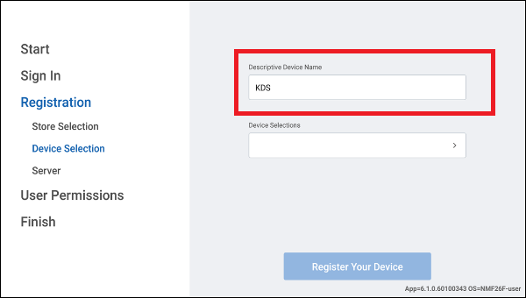

- Tap Device Selections. The Device Selection screen appears.

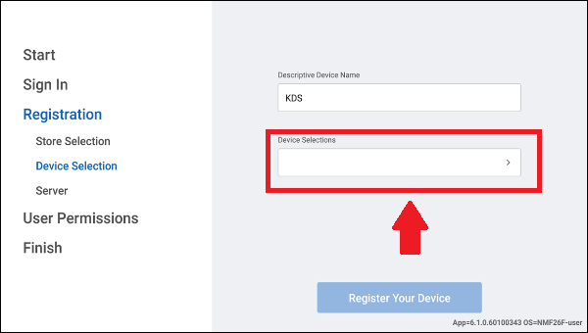

- Choose a station where you wish to register the device and tap DONE.

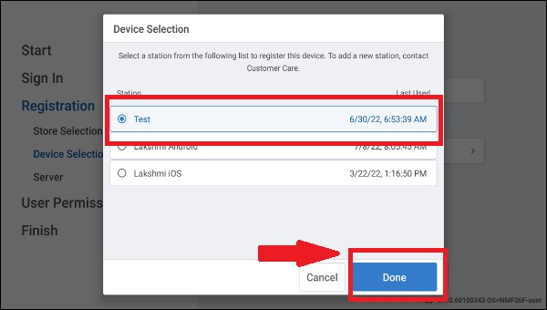

Note: (POS and Kitchen stations are set in Back Office prior to registering your devices. Once complete, the display device shows order information based on the routing configuration for the registered station).

Tap REGISTER YOUR DEVICE.

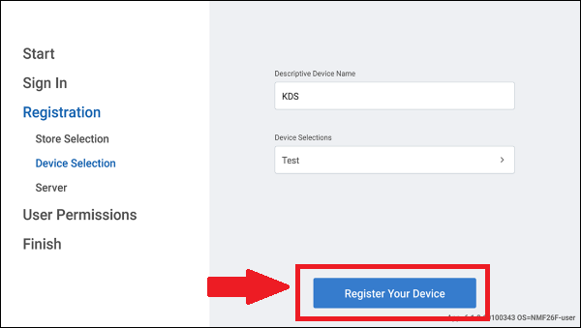

Note: If the customer does not want to register to the store server, he is able to skip and proceed to the next step.

- Type the server IP address or local DNS name or let the app automatically fetch the server
and tap Connect.
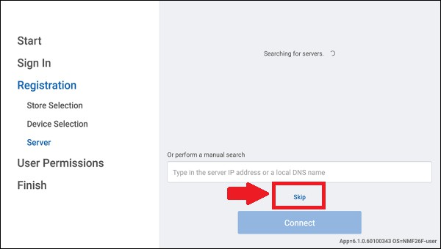

- Tap ALLOW PERMISSIONS.

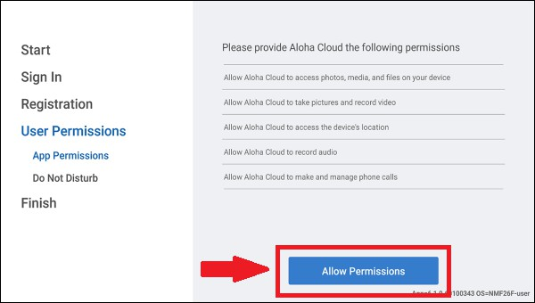

- Tap Allow for each permission requested. (toggle)
- Only enable Aloha Cloud.
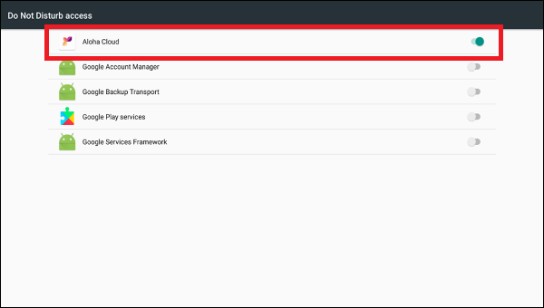

- Tap NEXT.
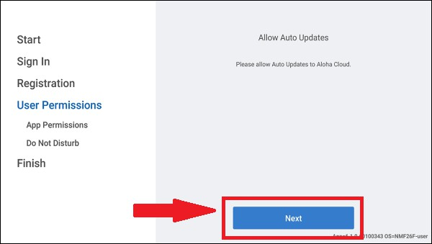

- Tap OK.
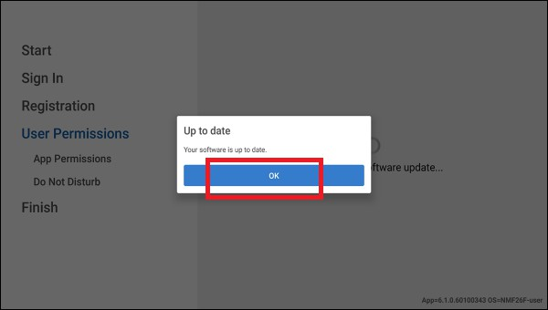

- Tap CONTINUE to complete the configuration.

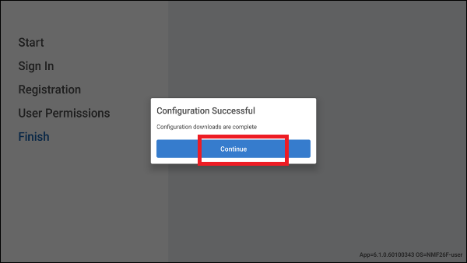

- The POS configuration is now complete. Next, we need to configure the receipt printer, kitchen printer, and cash drawer.

